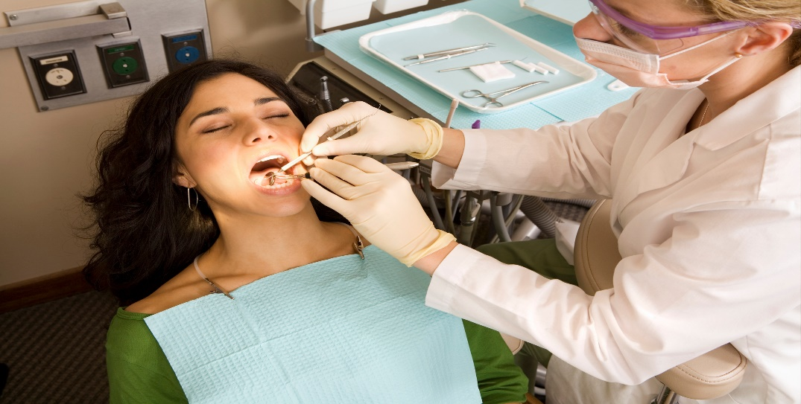
It’s Okay to not be Okay. But we want to help.
We are all feeling the increased stress brought on by an unwelcomed global pandemic, with COVID-19. Fear, increased anxiety, mood changes, relationship problems and family discord …. we are seeing the negative impact on people across our community. People are not quite feeling like their normal self, because we are not living in normal times. Dentist and all employees in a dental practice are considered essential healthcare workers that are important to the health of a community. We want to help find ways to keep our essential workers healthy and resilient. We recognize the stressful impact that COVID-19 has had on both the home life and work life. We understand, and we want to help.
ABBE CENTER and HILLCREST FAMILY SERVICES have partnered to offer all employees of dental practices in Benton, Buchanan, Bremer, Delaware, Dubuque, Iowa, Johnson, Jones and Linn Counties some FREE resources! This includes:
- Up to 5 individual sessions to talk individually about YOU, and how this global pandemic has impacted your life. Sessions will include tips on resiliency and how to help others that are struggling as well. For extra convenience, these sessions could be arranged by phone or telehealth.
- Individuals that are interested would also be invited to join a virtual support group to talk with their Peers and to provide mutual support.
- Handouts or video clips could also be made available to post in your clinic work areas.
- Presentations of “Make it Okay” are available to your team to learn how to open up crucial conversations about mental health.
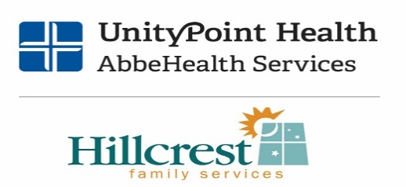
We see you. We care about you. And we want to help! Please contact us at the numbers below:

ABBE CENTER – 319-398-3562
HILLCREST FAMILY SERVICES – 563-207-5494

