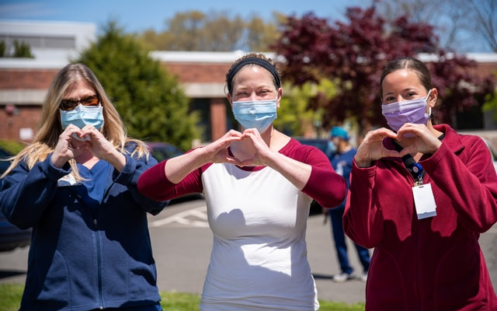
It’s Okay to not be Okay. But we want to help.
We are all feeling the increased stress brought on by an unwelcomed global pandemic, with COVID-19. Fear, increased anxiety, mood changes, relationship problems and family discord …. we are seeing the negative impact on people across our community. People are not quite feeling like their normal self, because we are not living in normal times. Long term care settings have been on the front line of this pandemic since the beginning. It is vital that we find ways to support our front line healthcare workers to keep them healthy and resilient. We recognize the stressful impact that COVID-19 has had on both people’s home life and work life. We understand, and we want to help.
ABBE CENTER and HILLCREST FAMILY SERVICES have partnered to offer ALL employees of long term care centers in Benton, Buchanan, Bremer, Delaware, Dubuque, Iowa, Johnson, Jones and Linn Counties some FREE resources! This includes:
- Up to 5 individual sessions to talk individually about YOU, and how this global pandemic has impacted your life. Sessions will include tips on resiliency and how to help others that are struggling as well. For extra convenience, these sessions could be arranged by phone or telehealth.
- Individuals that are interested would also be invited to join a virtual support group to talk with their Peers and to provide mutual support.
- Handouts, video clips or presentations are available to distribute to your staff or to post in work areas.
We see you. We care about you. And we want to help!
Please contact us at the numbers below:
ABBE CENTER – 319-398-3562
HILLCREST FAMILY SERVICES – 563-207-5494

