Over the Edge Global
www.overtheedgeglobal.com info@overtheedgeglobal.com

Community Wide Celebration
Fundraising Toolkit for Participants

Thank you for signing up to go Over The Edge for United Way of Dubuque Area Tri-States! We are thrilled to have you on board and have your help fulfilling our mission. This toolkit contains a number of exciting tips and tricks to increase your impact and fundraising efforts. Your engagement in fundraising and participating in our Over The Edge event will make a big difference in the lives of those in our community. The earlier that you get started the better!

FOR MORE HELP
Contact a Client Experience
Representative for tips or for
Fundraising Toolkit for Participants 1
answers to any questions on
our chat line from 9AM to
OVER THE EDGE GLOBAL

PHONE: 866-434-8776 EMAIL: info@overtheedgeglobal.com
5PM EST Monday to Friday:
www.overtheedgeglobal.com

Event Details

WHAT IS OVER THE EDGE?

Over The Edge is a special events company that provides signature events for non-profit organizations anywhere in North America and is currently expanding globally! Business leaders, individuals, and community members are invited to raise donations in exchange for the experience of going Over The
Edge of a local building. Over The Edge has raised over $80 million for non-profits around the world.

OUR MISSION

United Way of Dubuque Area Tri-States’ mission is to connect people and resources to advance the health, education and income/financial stability of those in need in the community.

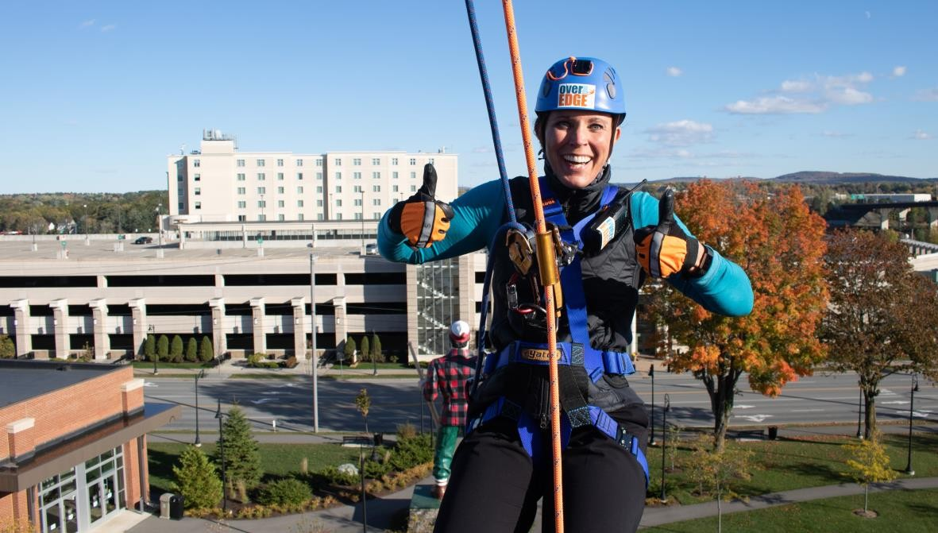

2 Fundraising Toolkit for Participant

EVENT FAQS

Minimum Age Requirement | Anyone can participate in an Over The Edge event. People in their 80s and 90s rappel! The only restriction is that anyone under the age of  18 requires a parent or guardian signature on the legal waiver.
Weight Requirement | Over The Edge’s equipment safety standards  require that people must be between 100 and  300 lbs in order to safely rappel.
Do I need to have experience to participate? | Not at all! I’ve included a document provided by Over The Edge on what to expect on event day! This document will tell you everything you need to know about the process from registration to the roof and back down again!
Fundraising Minimum | $1000
Number of rappel spots open | 80
How many Stories will you be rappelling | 8
Fundraising Deadline | Friday June 26, 2020
What should I wear to the event? | Dress comfortably! Do not wear overly loose or baggy clothing, or clothing with long drawstrings. Wear soft-soled, close-toed shoes or sneakers.
Can I wear a costume? | Costumes are allowed but are subject to the same limitations as baggy clothing. Every attempt will be made to safely fit costumes around harnesses and helmets. As with shorts, it is ultimately the decision of the Site Safety  Supervisor. Stringy, loose, or excessive costumes must be avoided. Head pieces that will not accommodate a helmet, obscure the vision, or are notably large or heavy will rarely be allowed.

Fundraising Toolkit for Participants

GETTING STARTED

Fundraising Made Easy!
Maximize your impact and invite your community to join your efforts.

• Step 1- Sign up! Visit our Over The Edge FundRazr page at https://give.overtheedge.events/oteuwdubuque2020
a. Click the ‘register’ button on their main page. Complete a brief registration form and a waiver. There is an $75 registration fee which will count towards your
fundraising goal. Your personal page will then be set up! Take advantage of this
opportunity to personalize your page by uploading a picture and/or video, setting your fundraising goal, and including a message about why you are participating! Take advantage of this opportunity to personalize your page by uploading a picture, setting your fundraising goal, and including a message about why you are participating!
• Step 2- Ask!
a. The number one reason that people give is because they are asked. Don’t be shy about telling everyone you know that you are participating in Over The Edge for United Way of Dubuque Area Tri-States. Don’t forget to go to places where you spend money like your hair salon, favorite restaurant, or your gym.

Beat the Average
Use this fun and easy plan to raise over half of your fundraising goal in only 6 weeks:

When? Who To Ask? Watch Your Total Grow!
Week 1 Use your online personal page to sponsor yourself $200
Week 2 Ask 6 Family Members/Friends for $25 each $150
Week 3 | Ask 6 Co-workers for $25 each | $150
Week 4 | Get 4 businesses you frequent to sponsor you for $100 each | $400
Week 5 | Ask your Boss to support your efforts | $250
Week 6 Ask 6 more Family Members/Friends for $25 each $150
Your 6-Week Grand Total $1300

4 Fundraising Toolkit for Participants

• Step 3- Follow Up!

Always follow up! Many people will need more than one request to donate and most will appreciate the reminder. Include fun facts and an update on how close you are to reaching your goal.

Send a thank you letter, note, or message to your donors. For your sponsors, consider including a crazy picture of you from the event so they remember you next year.

• Step 4- Reach your goal? Keep going!

Raise…

o $1,000

• Step 5- Have Fun! You’ve worked extremely hard to reach or surpass your goal. Get a group of family and friends together to watch you go Over The Edge. Take that time to take in the view and remember the good work you did here. Remember to post a photo after your event to your
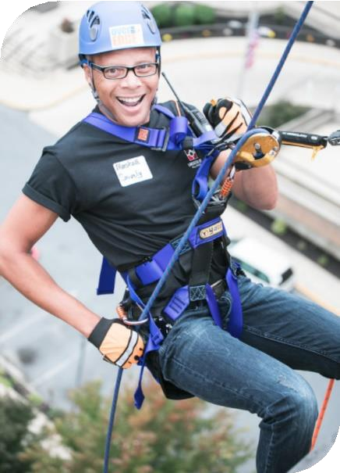social media accounts to show your supporters that you did it!

Fundraising Toolkit for Participants

HOW TO RAISE $1000

You’ve registered to go Over The Edge, you have the date circled on your
calendar, now what? Start fundraising today! Before you know it, you will have your $1000 raised and be on your way to the top!
Know your Facts!
Make sure you’re able to talk about our mission in terms of how the funds you ask for will make a difference. People give because they are asked, because they care, and because the person that is asking is passionate about the cause.

Best Practices
1. Start Early!
a. Although it may seem like you have all the time in the world to fundraise, this event will be here sooner than you think! The sooner you start fundraising, the more money you will raise for your non-profit and the sooner you will reach your goal.
b. Remember, as soon as you reach your goal, you will be able to secure your rappel spot!

2. Create an Email Schedule!
a. It is easy to be super keen when you start your fundraising journey, but lose steam a couple weeks in.
b. To make sure you are reaching out to your potential donors consistently, create an email schedule, with specific dates and diverse content.
c. This ensures that you will be switching up your messaging, so your potential donors are not receiving the same ask over and over again. Keep it interesting.
d. Suggested topics for your emails;
i. Ask your non-profit to provide mission related blurbs to add to your emails. This keeps your potential donors updated on WHY you are doing this and how it is helping.
ii. Include updates on where you are in the fundraising process and how much more you need to reach your goal.
iii. Include pictures and videos from Over the Edge – just ask us for them!

3. Get Help From Your Support System!
a. If your friends and colleagues are not able to donate, that’s OK! There is lots they can do to help you reach your goal;
b. Ask them to share your personal fundraising page on their social media forums

6 Fundraising Toolkit for Participants

c. Provide them with “info cards” about the event that include your fundraising website and ask that they distribute it to their network.
d. Ask them to reach out to the people in their lives that may have a connection to the mission, and would consider donating.

4. Make a Video!
a. As opposed to writing post after post on your social media forums, consider switching it up! Make a video detailing what you are doing and why you are doing it;
b. Most viewers will watch a video before they will read a post.
c. It is easier to communicate the mission of the non-profit profit you are supporting when you are speaking about it – the video makes it more personal.
d. Share this video to your social media pages and fundraising page!

5. Use Your Community Connections!
a. Get something donated from a business in your community
(gift certificate, swag bag, service, etc.)
b. Create a raise-athon week!
c. In your email and on social media use wording similar to this “Everyone
who donates to me this week, will go in a draw to win ”
Add the event logo to your
e-mail signature. You can also include a hyper-link to your personal fundraising page and encourage everyone to visit it and support your efforts.
d. At the end of the week, get someone to take a video of you drawing a name, and post it!
That person wins something, and you’ve made some extra money!

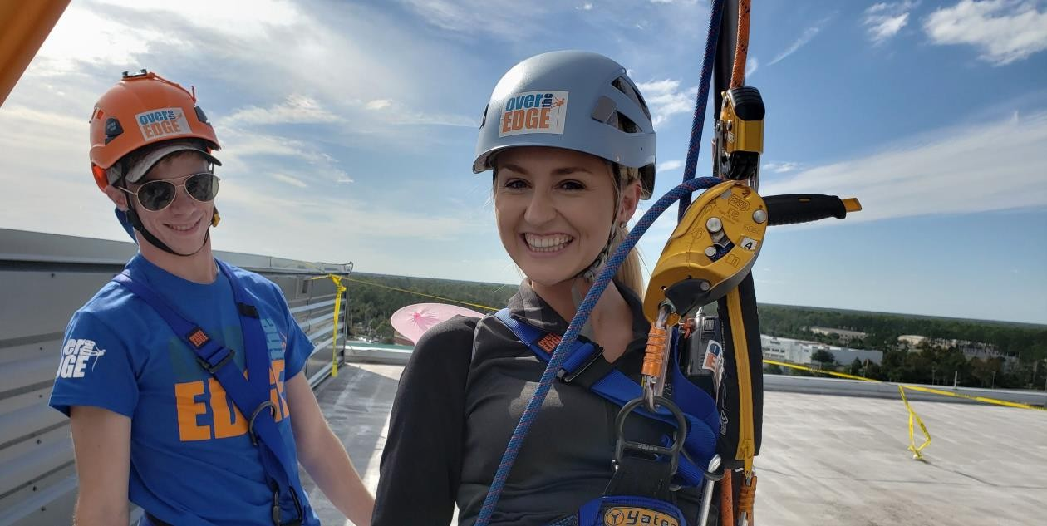

Fundraising Toolkit for Participants 7

Fundraising Inspiration
www.overtheedgeglobal.com info@overtheedgeglobal.com

• Floor sponsors and donations
o Divide the number of floors into your minimum amount raised
o $1000/20 floors, $50 pledge per floor

• Foot sponsors
o Same as floors, except use the height of the building in feet
o $1000/200 feet, $5 per foot

• Corporate matching
o Many companies will match charitable contributions their employees make. See if your company will match your donations or the total funds you raise. If they only match employee giving, get as many of your co-workers to give as possible.

• Corporate donations
o Don’t forget you can ask area businesses to support you.

• Office campaigns
o You can put together some mini-fundraisers to benefit your cause
o Bake sale – sell cookies at your desk.
o BBQ fundraiser (charge for lunch or ask for donations)
o Baskets – keep a donation plate on your desk or in a common area
o Challenge: have a peer in another department go Over the Edge with you and see who can raise the most money, or whoever raises the most has to go Over the Edge. For execs, challenge other departments or challenge an exec from another company!

8 Fundraising Toolkit for Participants

FUNDRAISERS

Fundraisers are really just excuses to have a party! Think of something that you and your friends and/or family like to do and make it a benefit to help you to get to be able to go Over the Edge in April.

Key Elements
Start planning early
• Promote your event
• Use social media and e-vites to spread the word quickly and cheaply
• Be sure to send out reminders as your event approaches
• Tell each quest to bring another friends or two
• Decide if you’ll be charging a flat rate or simply asking for a suggested donation
• Include a silent auction or raffle to increase donations at your event
• Pass around a jar at the event and ask people to donate their change

Don’t know what to plan??
We’ve included some great ideas for you below. Not everything on this list will appeal to you. Pick something that sounds like fun and start planning! If you need help on how to plan a great fundraiser, let us know. We are here to help!

• Babysitting by Donation Bachelor/Bachelorette Auction Bake Sale
• BBQ Cook Off
• Clothing Swap Night
• Be a Designated Driver- Ask for donations
• Benefit Concert Bingo Night
• Board Game Tournament Bowling Tournament
• Car Wash Chili/Spaghetti Cook Off
• Craft Show Dinner Party
• Dodgeball Tournament Dog Wash
• Garage Sale Holiday Bizarre Karaoke Night
• Kick Ball Tournament Movie Night
• Pancake Breakfast Pet Sitting
• Pizza Party
• Poker Tournament Raffle
• Scrapbook Party
• Sell Something on Ebay Silent Auction
• Snack Basket at Work Softball Tournament Trivia Party
• Volleyball Tournament Wine & Cheese Party

Fundraising Toolkit for Participants 9

FUNDRAISING WORKSHEET
Use this form to make a list of all possible donors to your fundraising effort. Once you have listed everyone you can think of and assigned an “ask” amount to each one, start fundraising and keep track!

Donor Name | Relationship to Me | Ask Amount | Received?
1.
2.
3.
4.
5.
6.
7.
8.
9.
10.
11.
12.
13.
14.
15.
16.
17.
18.
19.
20.

10 Fundraising Toolkit for Participants

Fundraising Letter Template:

Hello Family and Friends,

I have signed up to do something that many of you may think is crazy. I have joined Over The Edge in support of United Way of Dubuque Area Tri-States. Over The Edge is much like it sounds. I will stand on the roof of Hotel Julien Dubuque and step over the edge and rappel 8 stories to the ground! I’m not making this up…check out the event website https://dbqunitedway.org/over-the-edge

I am not asking you to rappel the building with me but I will need your support to get to the top. I am not only pledging to go Over The Edge, but I am also committing to raise $1,000 for United Way of Dubuque Area Tri-States, whose mission is to connect people and resources to advance the health, education and income/financial stability of those in need in our community.

How can you help? By making a 100% tax deductible donation to my website here: https://give.overtheedge.events/oteuwdubuque2020

You may also send checks or money orders made out to
United Way of Dubuque Area Tri-States
215 W. 6th Street
Dubuque, Iowa 52001

Please help me support the great work that United Way of Dubuque Area Tri-States is doing. I promise to rappel down a building in return!

Thank you for supporting United Way of Dubuque Area Tri-States and helping me to go OVER THE EDGE.

Sincerely,

(Your name here)

Fundraising Toolkit for Participants 11

Reminder Letter Template:

Hello Family and Friends,

Thank you so much to everyone that has already donated! I wanted to send you an update and let you know how my efforts to get to the top of Hotel Julien Dubuque is going. So far I have raised ($XXX). If I can raise $1,000 I truly will stand on the roof of Hotel Julien Dubuque and step Over The Edge and rappel 8 stories to the ground! I’m not making this up…check out the event website: https://dbqunitedway.org/over-the-edge

I am not asking you to rappel the building with me but I will need your support to get to the top. I am not only committing to raise awareness for United Way of Dubuque Area Tri-States by going Over The Edge, but I am also pledging to raise money to fund their mission to connect people and resources to advance the health, education and income/financial stability of those in need in our community.

How can you help? By making a 100% tax deductible donation to my website here:
https://give.overtheedge.events/oteuwdubuque2020

You may also send checks or money orders made out to
United Way of Dubuque Area Tri-States
215 W. 6th Street
Dubuque, Iowa 52001

Please help me support the great work that United Way of Dubuque Area Tri-States is doing. I promise to rappel from great heights!

If you have already donated or want to help even more, please feel free to pass this email along!

Thank you for supporting United Way of Dubuque Area Tri-States and helping me to go OVER THE EDGE!

Sincerely,

(Your name here)
12 Fundraising Toolkit for Participants

