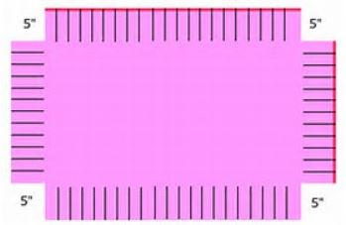
How to make a no-sew tie blanket:
Directions:
Items needed:
2 1/4 yards of printed or color fleece for top
2 1/4 yards of printed or color fleece for bottom
Scissors
Ruler/tape measure

•Lay the two pieces of fleece out of your work surface -- one on top of the other, with right sides facing out.

•Pin the pieces together, staying at least 4 inches away from the edge.

•Cut off the selvage edges or the whip-stitched edges, if you're using two ready-made blankets, with sharp fabric scissors.

•Cut a 5-inch square from each corner. Cut through both layers of fabric.

•Cut 5-inch long strips into the perimeter of the blanket, leaving an inch between cuts.

•Tie each strip from the top piece of fleece to the corresponding strip from the bottom piece of fleece to create a fringed edge. Work your way around all four sides to complete your no-sew fleece blanket.

http://www.ehow.com/how_2142255_nosew-fleece-blanket.html

