[BUSINESS NAME] PARTNERS WITH UNITED WAY

[Insert logo here]

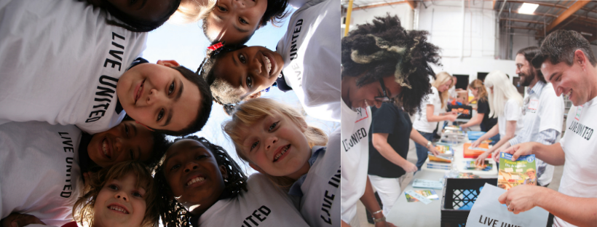

How Can I Get Involved?

Give:
Each year, United Way helps thousands of local lives, supporting the health, education and financial stability of our community. Feel free to make a cash/check donation or sign up for payroll deduct to make an impact today!

Advocate:
For information on area resources, contact United Way’s 2-1-1 Information and Referral line by calling or texting 2-1-1 or 1-866-469-2211. It’s a FREE, multi-lingual line available to provide you with local area resources. Otherwise, check out the FREE 2-1-1 Iowa App!

Volunteer:
Check our United Way’s Get Connected portal: http://dbqunitedway.galaxydigital.com/ Create your online profile and be matched to find a meaningful volunteer experience just for you!

