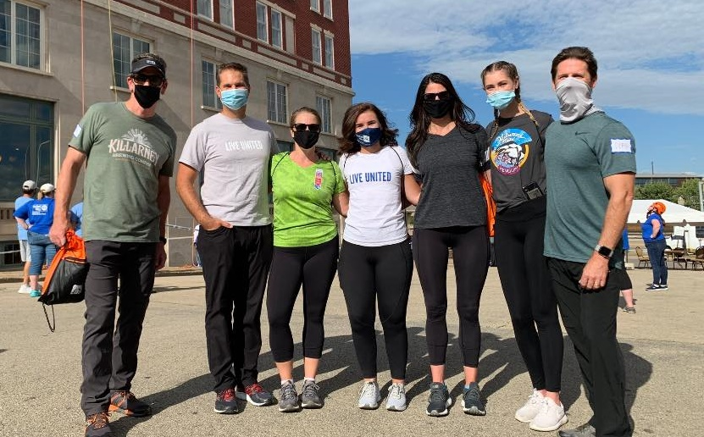

Want to change the photo?

Click on the picture, open the “format” tab, choose “change picture,” and pick a photo from your files. Resize as needed.

If the photo looks wonky after resizing, click the picture, open “format” tab, click the arrow under “Crop,” then “Fill.”



**About United Way**

United Way of Dubuque Area Tri-States is committed to the ideals of diversity and inclusion. We support health and human service programs that address community needs and encourage collaboration.

Our mission is to connect people and resources to advance the **health, education, and income**   
of those in need in   
our community.

Why do you support United Way?

Type your answer here.

Do you have a fundraising site? A goal?

Type your answer here.